## 

## 

## 

## CS302 Project 1

5-Bit Binary Adder with 7-Segment Display Control

Project Team 33

| الكود | الاسم |
| --- | --- |
| 2127493 | احمد محمد ابراهيم عزالدين |
| 2127109 | مصطفى انور مصطفى خفاجي |

# **Abstract**

# This project implements a 5-bit binary adder system that performs addition on two 5-bit binary numbers.

# The results are displayed using a 7-segment display, and the system supports a control bit to switch

# between decimal and hexadecimal representations for the inputs and outputs.

# 

# **Problem Definition**

## The main objective of the project is to:

# • Add two 5-bit binary numbers.

# • Display the operands and result on a 7-segment display.

# • Integrate a control unit for toggling between decimal and hexadecimal representation.

# 

# **System Architecture**

## The system comprises the following components:

# **5-bit Adder:** A modular circuit constructed using full adders, designed to handle 5-bit operands and produce a 6-bit output (including carry).

# **7-Segment Display:** Individual segments (A-G) designed and combined into a master circuit to display binary-to-decimal or binary-to-hexadecimal conversions.

# **Control Unit:** Enables switching between decimal and hexadecimal displays using a single control bit.

# **6x64 Decoder:** A 6x64 decoder maps the inputs to the appropriate segments of the display.

# 

# **Implementation**

## **3.1 - 5 bit Adder Circuit**

## The 5-bit adder was implemented using:

# Half Adders (HA): Used for the least significant bit addition.

# Full Adders (FA): Used for the remaining bits to propagate carry.

# The final output is a 6-bit result, where the extra bit represents the carry-out from the addition.

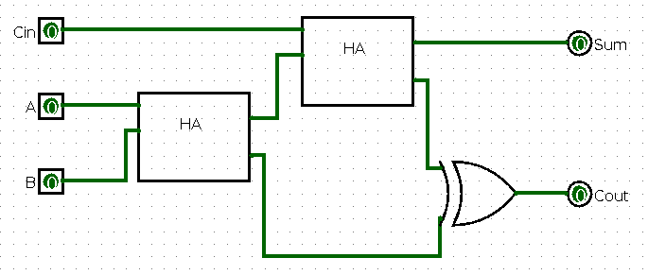**Full Adder using 2 Half Adder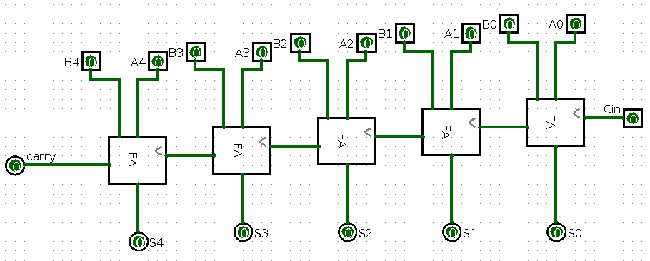5 bit Adder using 4 Full Adder**

## **3.2 - 7-Segment Display**

## The display system was designed with the following approach:

# A separate circuit for each segment (A-G).

# OR gates used to combine the output of the 6X64 decoder for each segment.

# Each segment is then combined into a master display system.

# 

# 

## **3.3 - Control Unit**

## The control unit uses enables to:

# Select between binary-to-decimal and binary-to-hexadecimal conversions.

# Enable or disable specific outputs on the 7-segment display.

* 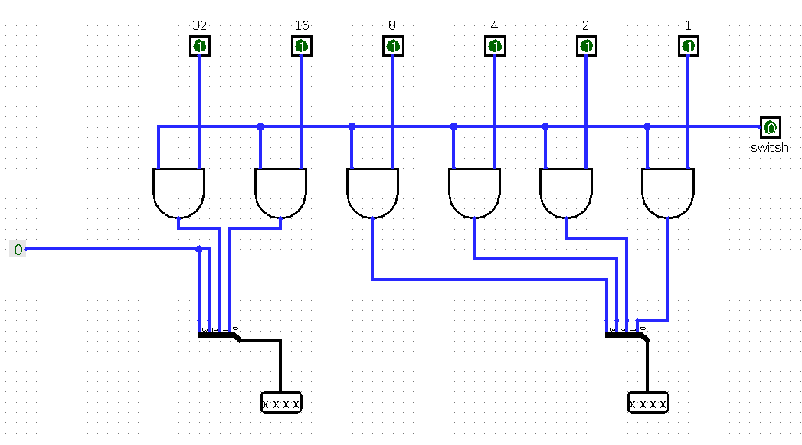

# 

# **Challenges Faced**

# **Keymap for 6 inputs:** Limited resources for keymap designs for 6-bit so decoders required using OR gates for manual mapping.

# **6X64 Decoder not exist by default in Logism:** The absence of a built-in 6x64 decoder in Logisim necessitated designing a custom decoder circuit. This was achieved by combining smaller decoders (e.g., 3x8 decoders) and using additional logic gates to manage outputs effectively.

# **Complexity of 7-Segment Design:** Mapping the outputs of the decoder to individual segments (A-G) involved extensive testing to ensure correct representation of numbers in both decimal and hexadecimal formats.

# **Results**

## The project successfully achieves the following:

* Accurate addition of 5-bit binary numbers.
* Display of inputs and results in both decimal and hexadecimal formats.
* Seamless switching using the control unit.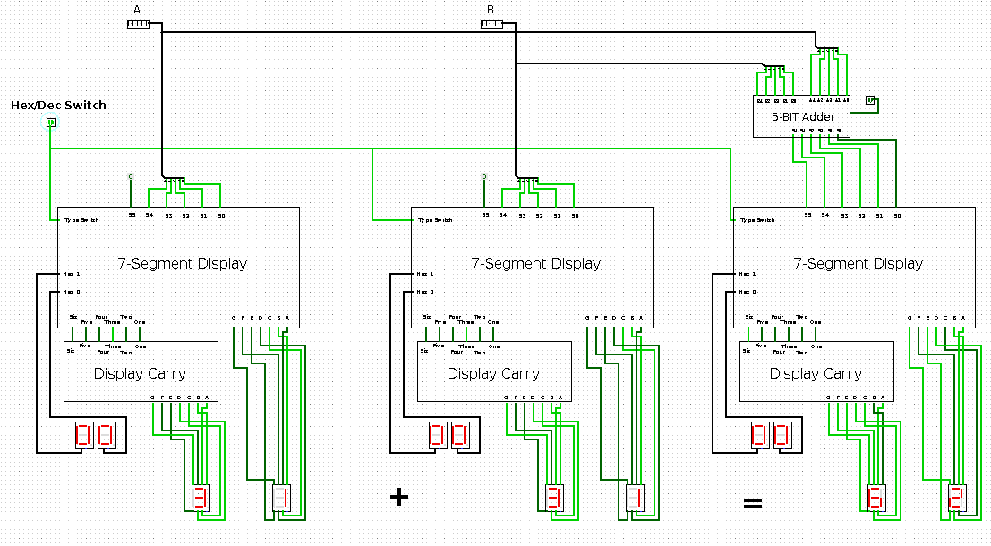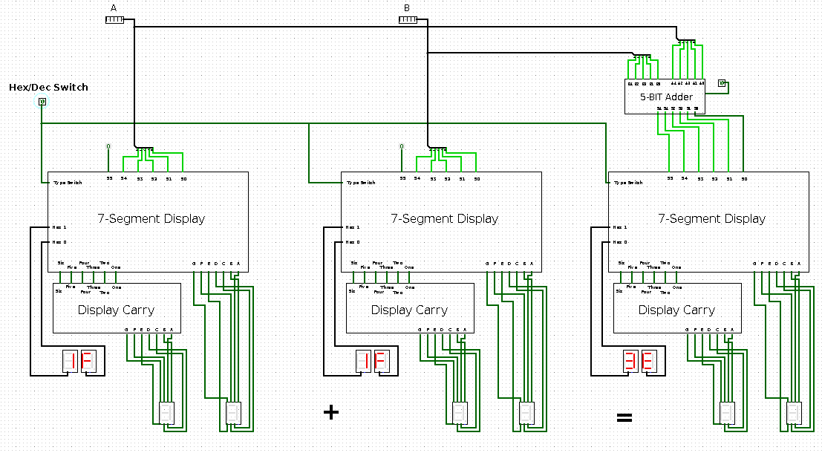

Figure 5: Overview of the main circuit in dec and hex

# **Conclusion**

# This project demonstrates the effective use of Logisim for designing and simulating digital systems.

# The modular approach ensures scalability and clarity, while the added functionality of a control unit enhances usability.

# *and thank you for your time.* ***Project Team 33 ❤️.***

# 

